Documentation Intranet Neuralink

Antoine CORDIER

2017



Sommaire

Cette documentation permettra de comprendre le fonctionnement de l’intranet, des niveaux back-end et front-end.

Support utilisé :

* OS : Linux/Ubuntu
* Développement : apache2, php7, MySQL-server
* Gestion : phpMyAdmin
* Logiciel Dev : phpStorm (jetbrains)
* API Google : Google Calendar
* Gestion du Calendrier : FullCalendar (Framework open source)
* Liaison : GLPI, OCS (création de la BDD + installation)
* Supervisons Nagios
* Ubuntu 16.04 LTS
  + Installation avec image ISO Ubuntu 16.04 LTS
  + Installation terminée :

Mise à jour des paquets

& apt-get update

& apt-get upgrade

* Installation de apache2, MySQL, PHP, phpMyAdmin
  + Apache2, PHP

& apt-get install apache2

& apt-get install php

Extension:

& apt-get install libapache2-mod-php

* + MySQL

& apt-get install mysql-server

Un mot de passe et une confirmation est demandé ne surtout pas perdre le mot de passe.

Import la base de donné

& mysql -u root -p

Entrer votre mot de passe MySQL

Copié le script SQL dans la terminale

La base de données est importée.

* Importation du projet réalisé
  + Ce placé à l’endroit souhaité soit « /var/www/html/ »

Ce dossier est créé lors de l’installation d’apache2 si vous ne l’avez pas refaites les étapes précédentes.

& cd /var/www/html/

Il vous suffit de télécharger votre projet placer dans un hébergeur ou bien sur un projet git

& wget {{URL http/https}}

& unzip /var/www/html/{{filename}}

* Configuration d’apache
  + Modifié le fichier par défaut d’affichage de l’adresse de la machine

Soit <http://192.168.1.7/> pointe directement sur le projet.

Vous pouvez installer vim pour modifier les fichiers dans la terminale ou nano

& apt-get install vim

& apt-get install nano

& sudo nano /etc/apache2/apache2.conf

Trouver dans le fichier

<Directory /var/www/html/>

Options Indexes FollowSymLinks

AllowOverride None

Require all granted

</Directory>

Modifié /var/www/html/{{filename}}

Relancez apache

Service apache2 restart

* Gestion

phpMyAdmin



(PMA) est une application Web de gestion pour les systèmes de gestion de base de données MySQL réalisée en PHP et distribuée sous licence GNU GPL.

* + Installation

& apt-get install phpmyadmin

Bien appuyer sur espace sur apache2

Pour valider l’utilisation d’apache

Demande du mot passe MySQL root

Une fois l’installation terminé

<http://192.168.1.7/phpmyadmin>

* Logiciel Dev



JetBrains est une entreprise informatique éditant des logiciels pour développeurs de logiciels. JetBrains a des bureaux à Prague, Saint-Pétersbourg, Boston, Moscou et Munich.

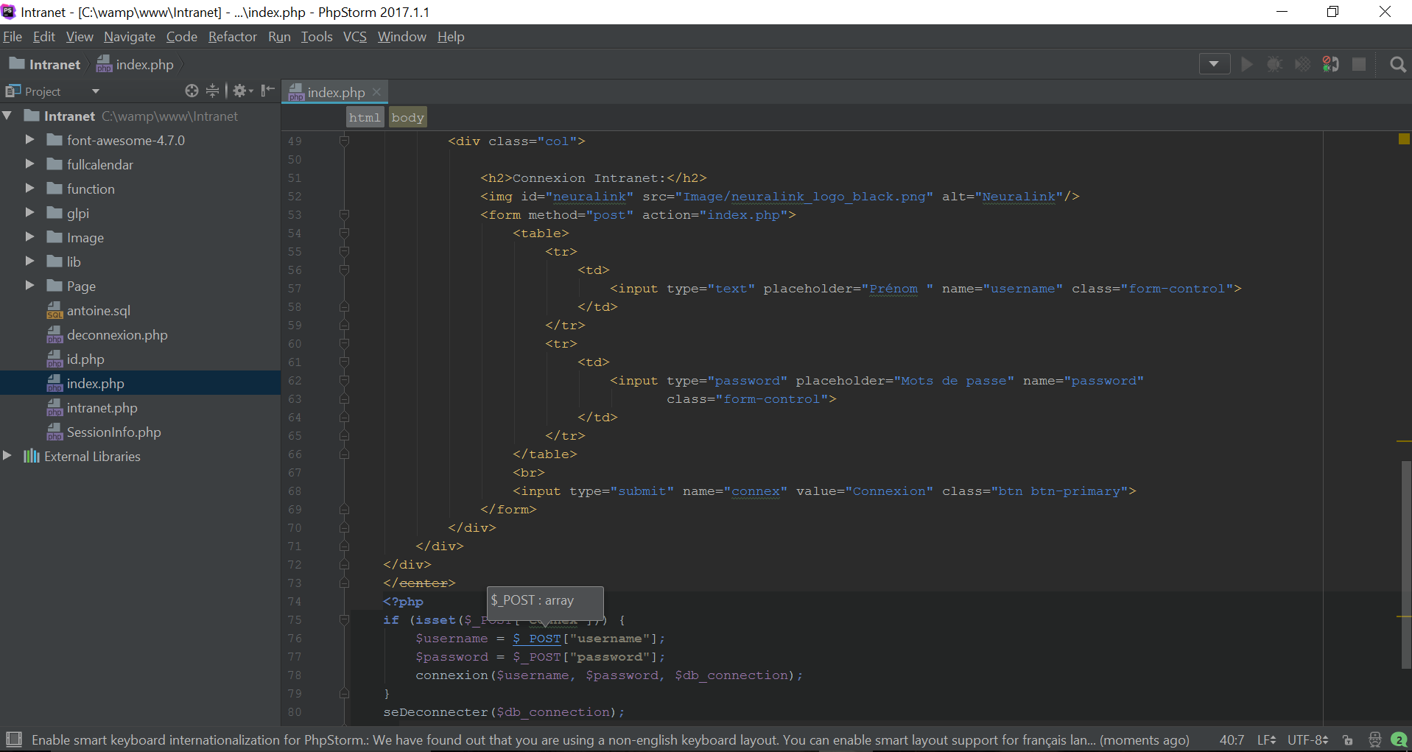

Adapter pour une utilisation de PHP permet de trouver rapidement une erreur une auto complétion pousser sur le PHP, html, ccs, JavaScript et d’autre langage.

Capable de lire les chemins des fichiers change le nom d’un fichier dans tous les fichiers appeler s’il est modifié.

Il a été un outil essentiel au développement de l’intranet.

* Ajout de GLPI OCS

OCS Inventory

Qu'est-ce que OCS Inventory ?

OCS Inventory NG (Open Computers and Software Inventory Next Generation), est un outil permettant d'effectuer un inventaire automatisé d'un parc informatique.

Accessible depuis une interface web, OCS va permettre de visualiser l'inventaire de votre parc.

Il vous sera simple de visualiser par exemple le nombre de machine sous l'OS* Windows 7 que dispose votre parc, ainsi que d'autres éléments comme la mémoire vive, ou le processeur.

Cette application va permettre aussi la télédiffusion d'application.

OCS Inventory peut être couplé avec d'autres applications telles que GLPI que nous verrons également dans cet article.

Cette application est diffusée sous licence GNU GPL.

GLPI

Qu'est-ce que GLPI ?

GLPI (Gestion Libre de Parc Informatique), est une application destinée à la gestion de parc informatique.

Utilisant le langage de programmation PHP, GLPI permet de récolter et gérer l'intégralité des composantes matérielles ou logiciels d'un parc informatique.

Il permettra donc d'optimiser la maintenance des postes.

Les fonctionnalités

GLPI intègre de nombreuse fonctionnalités telles que :

Inventaire des ordinateurs, périphériques (Clavier, souris...), imprimantes et autres consommable.

Gestion des licences

Gestion des réparations

Gestions des fournisseurs, Contrats, documents (ex : bon de commande d'un poste)

Réservation de matériel

Help desk

Il faut être root sur la machine (ubuntu 16.04 LTS)

Mise à jour :

apt-get update

apt-get upgrade

OCS Inventory requiert :

* Apache (Serveur web)
* PHP
* PERL
* MySQL
* Make

Apache (Serveur web)

apt-get install apache2 apache2-doc

Package Make

apt-get install make

Installation PHP

apt-get install php libapache2-mod-php php-mysql php-gd

Installation MySQL

apt-get install mysql-server

(Ajout possible de PHPMYAdMIN)

apt-get install phpmyadmin

Installation Perl

apt-get install libxml-simple-perl

apt-get install libio-compress-perl

apt-get install libc-dev

apt-get install libdbi-perl

apt-get install libdbd-mysql-perl

apt-get install libapache-dbi-perl

apt-get install libnet-ip-perl

apt-get install libsoap-lite-perl

Téléchargement & Installation d'OCS Inventory

wget https://github.com/OCSInventory-NG/OCSInventory-ocsreports/releases/download/2.2.1/OCSNG_UNIX_SERVER-2.2.1.tar.gz

tar -xzvf OCSNG_UNIX_SERVER-2.2.1.tar.gz

cd OCSNG_UNIX_SERVER-2.2.1

./setup.sh

+----------------------------------------------------------+

|                                                          |

|  Welcome to OCS Inventory NG Management server setup !   |

|                                                          |

+----------------------------------------------------------+

Trying to determine whitch OS or Linux distribution you use

+----------------------------------------------------------+

| Checking for Apache web server binaries !                             |

+----------------------------------------------------------+

CAUTION: If upgrading Communication server from OCS Inventory NG 1.0 RC2 and

previous, please remove any Apache configuration for Communication Server!

Do you wish to continue ([y]/n)?

Assuming Communication server 1.0 RC2 or previous is not installed

on this computer.

Starting OCS Inventory NG Management server setup from folder /home/supinfo/OCSNG_UNIX_SERVER-2.2.1

Storing log in file /home/supinfo/OCSNG_UNIX_SERVER-2.2.1/ocs_server_setup.log

+----------------------------------------------------------+

| Checking for database server properties...                      |

+----------------------------------------------------------+

Your MySQL client seems to be part of MySQL version 10.0.

Your computer seems to be running MySQL 4.1 or higher, good ;-)

Which host is running database server [localhost] ?

OK, database server is running on host localhost ;-)

On which port is running database server [3306] ?

OK, database server is running on port 3306 ;-)

+----------------------------------------------------------+

| Checking for Apache web server daemon...                              |

+----------------------------------------------------------+

Where is Apache daemon binary [/usr/sbin/apache2ctl] ?

OK, using Apache daemon /usr/sbin/apache2ctl ;-)

+----------------------------------------------------------+

| Checking for Apache main configuration file...                  |

+----------------------------------------------------------+

AH00558: apache2: Could not reliably determine the server's fully qualified domain name, using 127.0.1.1. Set the 'ServerName' directive globally to suppress this message

AH00558: apache2: Could not reliably determine the server's fully qualified domain name, using 127.0.1.1. Set the 'ServerName' directive globally to suppress this message

Where is Apache main configuration file [/etc/apache2/apache2.conf] ?

OK, using Apache main configuration file /etc/apache2/apache2.conf ;-)

+----------------------------------------------------------+

| Checking for Apache user account...                                    |

+----------------------------------------------------------+

Which user account is running Apache web server [www-data] ?

OK, Apache is running under user account www-data ;-)

+----------------------------------------------------------+

| Checking for Apache group...                                                 |

+----------------------------------------------------------+

Which user group is running Apache web server [www-data] ?

OK, Apache is running under users group www-data ;-)

+----------------------------------------------------------+

| Checking for Apache Include configuration directory...   |

+----------------------------------------------------------+

Setup found Apache Include configuration directory in

/etc/apache2/conf-available.

Setup will put OCS Inventory NG Apache configuration in this directory.

Where is Apache Include configuration directory [/etc/apache2/conf-available] ?

OK, Apache Include configuration directory /etc/apache2/conf-available found ;-)

+----------------------------------------------------------+

| Checking for PERL Interpreter...                                             |

+----------------------------------------------------------+

Found PERL Intrepreter at </usr/bin/perl> ;-)

Where is PERL Intrepreter binary [/usr/bin/perl] ?

OK, using PERL Intrepreter /usr/bin/perl ;-)

Do you wish to setup Communication server on this computer ([y]/n)?

+----------------------------------------------------------+

|             Checking for Make utility...                 |

+----------------------------------------------------------+

OK, Make utility found at </usr/bin/make> ;-)

+----------------------------------------------------------+

|        Checking for Apache mod_perl version...           |

+----------------------------------------------------------+

Checking for Apache mod_perl version 1.99_22 or higher

Found that mod_perl version 1.99_22 or higher is available.

OK, Apache is using mod_perl version 1.99_22 or higher ;-)

+----------------------------------------------------------+

|    Checking for Communication server log directory...    |

+----------------------------------------------------------+

Communication server can create detailed logs. This logs can be enabled

by setting integer value of LOGLEVEL to 1 in Administration console

menu Configuration.

Where to put Communication server log directory [/var/log/ocsinventory-server] ?

OK, Communication server will put logs into directory /var/log/ocsinventory-server ;-)

+----------------------------------------------------------------------------+

|    Checking for Communication server plugins configuration directory...    |

+----------------------------------------------------------------------------+

Communication server need a directory for plugins configuration files.

Where to put Communication server plugins configuration files [/etc/ocsinventory-server/plugins] ?

OK, Communication server will put plugins configuration files into directory /etc/ocsinventory-server/plugins ;-)

+-------------------------------------------------------------------+

|   Checking for Communication server plugins perl directory...     |

+-------------------------------------------------------------------+

Communication server need a directory for plugins Perl modules files.

Where to put Communication server plugins Perl modules files [/etc/ocsinventory-server/perl] ?

OK, Communication server will put plugins Perl modules files into directory /etc/ocsinventory-server/perl ;-)

+----------------------------------------------------------+

| Checking for required Perl Modules...                                 |

+----------------------------------------------------------+

Checking for DBI PERL module...

Found that PERL module DBI is available.

Checking for Apache::DBI PERL module...

Found that PERL module Apache::DBI is available.

Checking for DBD::mysql PERL module...

Found that PERL module DBD::mysql is available.

Checking for Compress::Zlib PERL module...

Found that PERL module Compress::Zlib is available.

Checking for XML::Simple PERL module...

Found that PERL module XML::Simple is available.

Checking for Net::IP PERL module...

Found that PERL module Net::IP is available.

Checking for SOAP::Lite Perl module...

Found that PERL module SOAP::Lite is available.

Checking for Archive::Zip Perl module...

*** ERROR: PERL module Archive::Zip is not installed !

*** ERROR: There is one or more required PERL modules missing on your computer !

Please, install missing PERL modules first.

OCS setup.sh can install perl module from packages for you

The script will use the native package from your operating system like apt or rpm

Do you wish to continue (y/[n])?y

Debian based automatic installation

Hit:1 http://security.ubuntu.com/ubuntu xenial-security InRelease

Hit:2 http://fr.archive.ubuntu.com/ubuntu xenial InRelease

Get:3 http://fr.archive.ubuntu.com/ubuntu xenial-updates InRelease [95.7 kB]

Get:4 http://fr.archive.ubuntu.com/ubuntu xenial-backports InRelease [92.2 kB]

Fetched 188 kB in 1s (108 kB/s)

Reading package lists... Done

Reading package lists... Done

Building dependency tree

Reading state information... Done

libsoap-lite-perl is already the newest version (1.19-1).

0 upgraded, 0 newly installed, 0 to remove and 5 not upgraded.

All packages have been installed on this computer

+----------------------------------------------------------+

|         Checking for optional Perl Modules...            |

+----------------------------------------------------------+

Checking for Apache2::SOAP PERL module...

*** Warning: PERL module Apache2::SOAP is not installed !

This module is only required by OCS Inventory NG SOAP Web Service.

Do you wish to continue ([y]/n] ?

Checking for XML::Entities PERL module...

*** Warning: PERL module XML::Entities is not installed !

This module is only required by OCS Inventory NG SOAP Web Service.

Do you wish to continue ([y]/n] ?

+----------------------------------------------------------+

|                 OK, looks good ;-)                       |

|                                                          |

|     Configuring Communication server Perl modules...     |

+----------------------------------------------------------+

Checking if your kit is complete...

Looks good

Generating a Unix-style Makefile

Writing Makefile for Apache::Ocsinventory

Writing MYMETA.yml and MYMETA.json

+----------------------------------------------------------+

|                 OK, looks good ;-)                       |

|                                                          |

|      Preparing Communication server Perl modules...      |

+----------------------------------------------------------+

+----------------------------------------------------------+

|                 OK, prepare finshed ;-)                  |

|                                                          |

|     Installing Communication server Perl modules...      |

+----------------------------------------------------------+

+----------------------------------------------------------+

| OK, Communication server Perl modules install finished;-)|

|                                                          |

|     Creating Communication server log directory...       |

+----------------------------------------------------------+

Creating Communication server log directory /var/log/ocsinventory-server.

Fixing Communication server log directory files permissions.

Configuring logrotate for Communication server.

Removing old communication server logrotate file /etc/logrotate.d/ocsinventory-NG

Writing communication server logrotate to file /etc/logrotate.d/ocsinventory-server

+----------------------------------------------------------------------+

|        OK, Communication server log directory created ;-)            |

|                                                                      |

|   Creating Communication server plugins configuration directory...   |

+----------------------------------------------------------------------+

Creating Communication server plugins configuration directory /etc/ocsinventory-server/plugins.

+----------------------------------------------------------------------+

| OK, Communication server plugins configuration directory created ;-) |

|                                                                      |

|        Creating Communication server plugins Perl directory...       |

+----------------------------------------------------------------------+

Creating Communication server plugins Perl directory /etc/ocsinventory-server/perl.

+----------------------------------------------------------------------+

|     OK, Communication server plugins Perl directory created ;-)      |

|                                                                      |

|               Now configuring Apache web server...                   |

+----------------------------------------------------------------------+

To ensure Apache loads mod_perl before OCS Inventory NG Communication Server,

Setup can name Communication Server Apache configuration file

'z-ocsinventory-server.conf' instead of 'ocsinventory-server.conf'.

Do you allow Setup renaming Communication Server Apache configuration file

to 'z-ocsinventory-server.conf' ([y]/n) ?

OK, using 'z-ocsinventory-server.conf' as Communication Server Apache configuration file

Removing old communication server configuration to file /etc/apache2/conf-available/ocsinventory.conf

Writing communication server configuration to file /etc/apache2/conf-available/z-ocsinventory-server.conf

+----------------------------------------------------------------------+

|       OK, Communication server setup successfully finished ;-)       |

|                                                                      |

| Please, review /etc/apache2/conf-available/z-ocsinventory-server.conf |

|         to ensure all is good. Then restart Apache daemon.           |

+----------------------------------------------------------------------+

Do you wish to setup Administration Server (Web Administration Console)

on this computer ([y]/n)?

+----------------------------------------------------------+

|    Checking for Administration Server directories...     |

+----------------------------------------------------------+

CAUTION: Setup now install files in accordance with Filesystem Hierarchy

Standard. So, no file is installed under Apache root document directory

(Refer to Apache configuration files to locate it).

If you're upgrading from OCS Inventory NG Server 1.01 and previous, YOU

MUST REMOVE (or move) directories 'ocsreports' and 'download' from Apache

root document directory.

If you choose to move directory, YOU MUST MOVE 'download' directory to

Administration Server writable/cache directory (by default

/var/lib/ocsinventory-reports), especially if you use deployment feature.

Do you wish to continue ([y]/n)?

Assuming directories 'ocsreports' and 'download' removed from

Apache root document directory.

Where to copy Administration Server static files for PHP Web Console

[/usr/share/ocsinventory-reports] ?

OK, using directory /usr/share/ocsinventory-reports to install static files ;-)

Where to create writable/cache directories for deployment packages,

administration console logs, IPDiscover and SNMP [/var/lib/ocsinventory-reports] ?

OK, writable/cache directory is /var/lib/ocsinventory-reports ;-)

+----------------------------------------------------------+

|         Checking for required Perl Modules...            |

+----------------------------------------------------------+

Checking for DBI PERL module...

Found that PERL module DBI is available.

Checking for DBD::mysql PERL module...

Found that PERL module DBD::mysql is available.

Checking for XML::Simple PERL module...

Found that PERL module XML::Simple is available.

Checking for Net::IP PERL module...

Found that PERL module Net::IP is available.

+----------------------------------------------------------+

|      Installing files for Administration server...       |

+----------------------------------------------------------+

Creating PHP directory /usr/share/ocsinventory-reports/ocsreports.

Copying PHP files to /usr/share/ocsinventory-reports/ocsreports.

Fixing permissions on directory /usr/share/ocsinventory-reports/ocsreports.

Creating database configuration file /usr/share/ocsinventory-reports/ocsreports/dbconfig.inc.php.

Creating IPDiscover directory /var/lib/ocsinventory-reports/ipd.

Fixing permissions on directory /var/lib/ocsinventory-reports/ipd.

Creating packages directory /var/lib/ocsinventory-reports/download.

Fixing permissions on directory /var/lib/ocsinventory-reports/download.

Creating snmp mibs directory /var/lib/ocsinventory-reports/snmp.

Fixing permissions on directory /var/lib/ocsinventory-reports/snmp.

Creating Administration server log files directory /var/lib/ocsinventory-reports/logs.

Fixing permissions on directory /var/lib/ocsinventory-reports/logs.

Creating Administration server scripts log files directory /var/lib/ocsinventory-reports/scripts.

Fixing permissions on directory /var/lib/ocsinventory-reports/scripts.

Configuring IPDISCOVER-UTIL Perl script.

Installing IPDISCOVER-UTIL Perl script.

Fixing permissions on IPDISCOVER-UTIL Perl script.

Writing Administration server configuration to file /etc/apache2/conf-available/ocsinventory-reports.conf

+----------------------------------------------------------------------+

|        OK, Administration server installation finished ;-)           |

|                                                                      |

| Please, review /etc/apache2/conf-available/ocsinventory-reports.conf

|          to ensure all is good and restart Apache daemon.            |

|                                                                      |

| Then, point your browser to http://server//ocsreports

|        to configure database server and create/update schema.        |

+----------------------------------------------------------------------+

Setup has created a log file /home/supinfo/OCSNG_UNIX_SERVER-2.2.1/ocs_server_setup.log. Please, save this file.

If you encounter error while running OCS Inventory NG Management server,

we can ask you to show us his content !

DON'T FORGET TO RESTART APACHE DAEMON !

Enjoy OCS Inventory NG ;-)

root@srv-inventory:/home/supinfo/OCSNG_UNIX_SERVER-2.2.1#

cp /etc/apache2/conf-available/z-ocsinventory-server.conf /etc/apache2/sites-enabled

sudo cp /etc/apache2/conf-available/ocsinventory-reports.conf /etc/apache2/sites-enabled

service apache2 stop

service apache2 start

Installation d’un package

apt-get install php-soap

apt-get install php-xml

apt-get install php-mbstring

service apache2 stop

service apache2 start

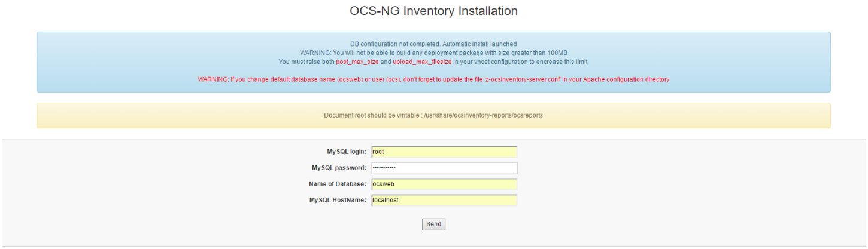

Utilisateur : admin

Mots de passe : admin

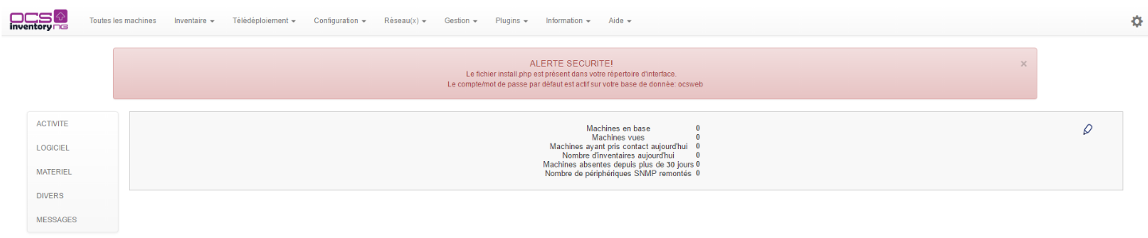

Installation agent sur Windows 7 (exemple)

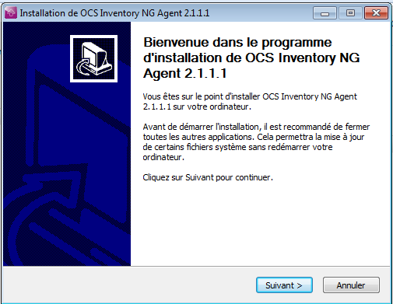

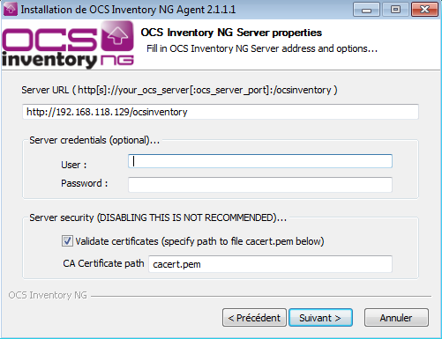

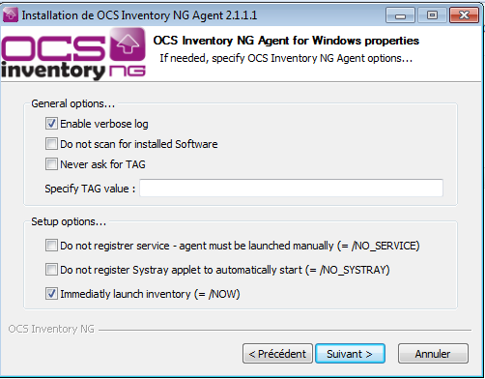

Téléchargement & Installation GLPI

Cd /var/www/html

wget https://github.com/glpi-project/glpi/releases/download/0.90.4/glpi-0.90.4.tar.gz

tar -xzvf glpi-0.90.4.tar.gz

chmod 777 -R /var/www/html/glpi

sudo apt-get install php-curl

service apache2 stop

service apache2 start

Aller dans localhost/glpi



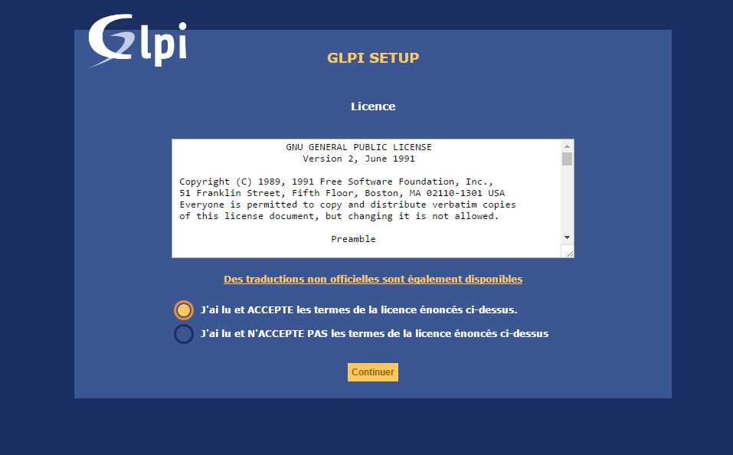

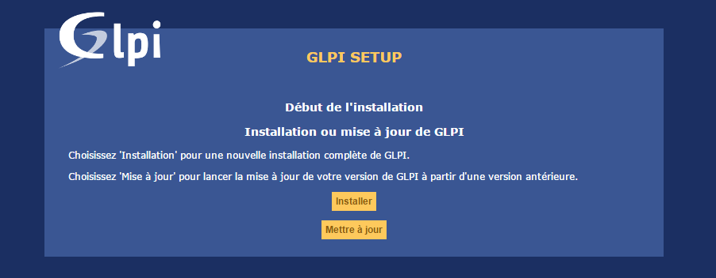

apt-get install php-imap

imap: mail

apt-get install php-ldap

Active directory gestion des utilisateurs

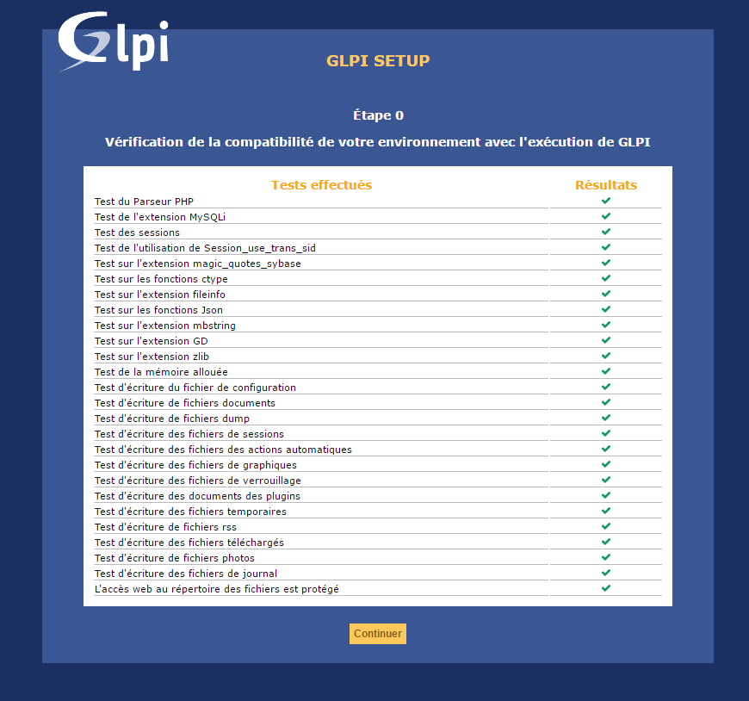

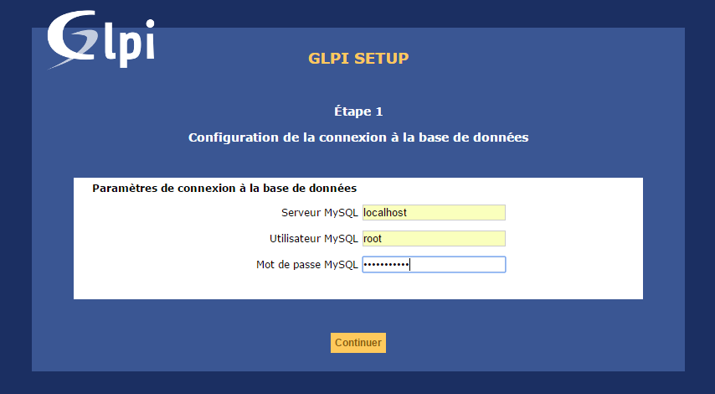

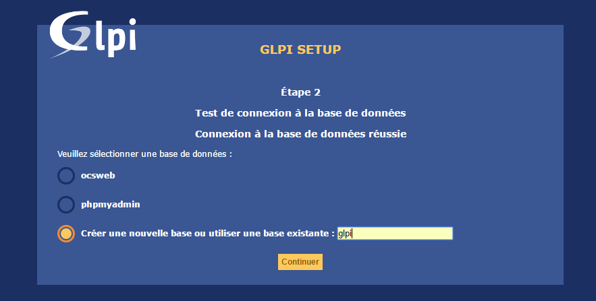



Utilisateur : glpi

Mots de passe : glpi

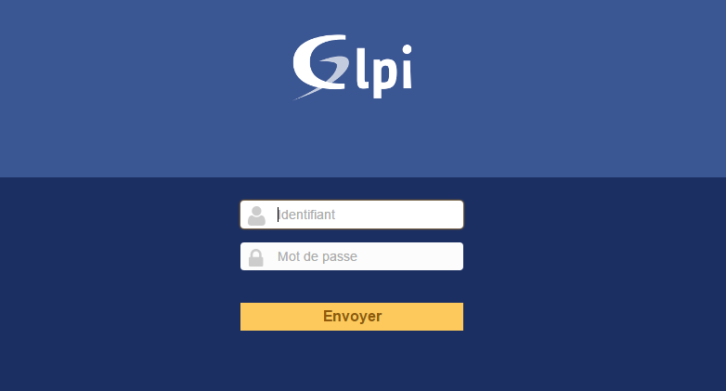

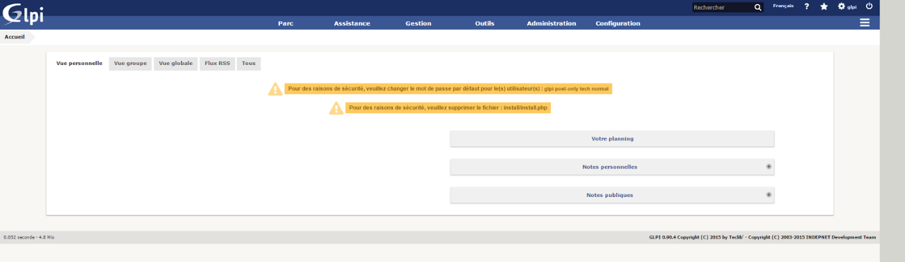

cd /var/www/html/glpi/install

rm -f install.php

Vous pouvez changer les mots de passe par défaut des comptes ou les supprimés.

Plugin pour importer base de donné OCS

cd /var/www/html/glpi/plugins

wget https://github.com/pluginsGLPI/ocsinventoryng/releases/download/1.2.1/glpi-ocsinventoryng-1.2.1.tar.gz

tar -xzvf glpi-ocsinventoryng-1.2.1.tar.gz

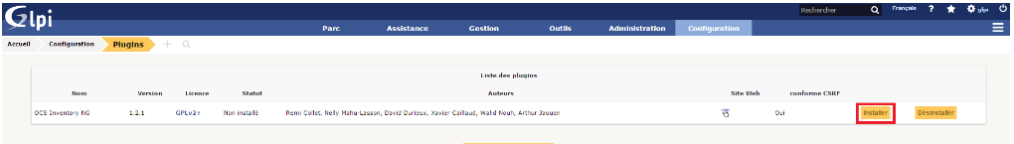

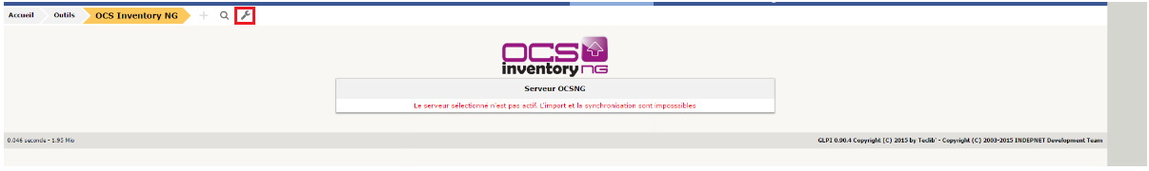

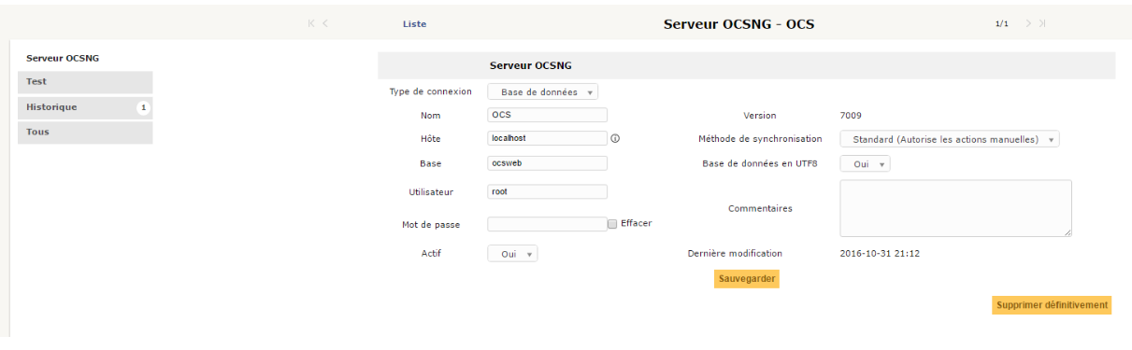

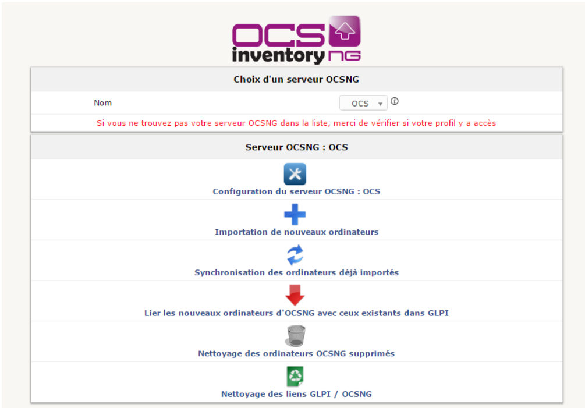

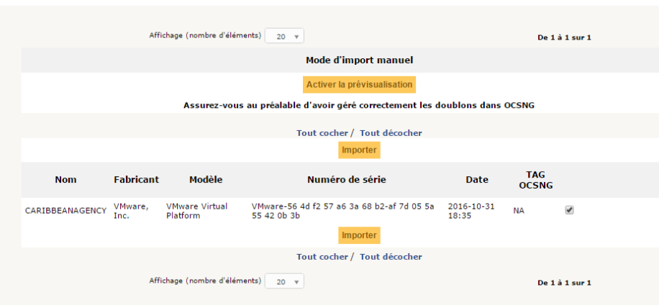

* Supervision

Nagios



Nagios (anciennement appelé Netsaint) est une application permettant la surveillance système et réseau. Elle surveille les hôtes et services spécifiés, alertant lorsque les systèmes ont des dysfonctionnements et quand ils repassent en fonctionnement normal. C'est un logiciel libre sous licence GPL.

C'est un programme modulaire qui se décompose en trois parties :

* + Le moteur de l'application qui vient ordonnancer les tâches de supervision.
  + L'interface web, qui permet d'avoir une vue d'ensemble du système d'information et des possibles anomalies.
  + Les sondes (appelées greffons ou plugins), une centaine de mini programmes que l'on peut compléter en fonction des besoins de chacun pour superviser chaque service ou ressource disponible sur l'ensemble des ordinateurs ou éléments réseaux du SI.
  + Installation

& apt-get install nagios3

Le mot est demandé pendant l’installation.

Il s’agit de seule commande pour installer Nagios

L’interface web est disponible :

Soit

<http://localhost/nagios3>

Où

<http://192.168.1.7/nagios3>

Pour aller sur l’interface

* + Configuration des check

Définir un host /etc/nagios3/conf.d/localhost_nagios2.cfg

Ajouter un host.

define host {

use generic-host

host_name Windows-server

alias Windows-server

address 192.168.1.5

}

Ajouter un service ici un simple Ping.

#ping windows server

define service {

use generic-service

host_name Windows-server

service_description ping

check_command check_ping!100.0,20%!500.0,60%

}

& Sudo service nagios3 reload

Après chaque modification faire cette commande.